We developed an air quality monitoring system to measure the co2 levels, humidity, temperature and other external gasses like smoke, methane etc.

For this project, we utilized the Raspberry Pi 3 Model B as the main computing unit to integrate all the sensors and components. The Raspberry Pi provided a powerful yet compact platform with support for Python, which was our chosen programming language for the project.

First, we made sure that the Python and pip were correctly installed on Raspberry Pi using the following command in bash:

sudo apt-get install python3 python3-pip

Next, we installed the ‘RPi.GPIO’ library to work with the GPIO pins. This library allowed us to interact with the pins programmatically, enabling us to read input from sensors and send output signals to actuators. The installation command is:

sudo apt-get install python3-rpi.gpio

The primary sensor used for CO2 detection was the MH-Z19B. We used the ‘mh-z19b’ library to interface with the MH-Z19B sensor.

pip install mh-z19

For detecting external gases, we used the MQ-2 sensor. This sensor communicates with the Raspberry Pi through analog and digital pins, and we interfaced it accordingly.

To monitor temperature and humidity, we integrated the DHT11 sensor from Generic.

This sensor uses a single-wire protocol to communicate with the Raspberry Pi. We utilized the ‘Adafruit_DHT’ library for Python to work with the DHT11 sensor and retrieve temperature and humidity readings.

pip install Adafruit_DHT

Initially, we used PuTTY to interact with Raspberry Pi. However, it frequently asked for credentials, which was time-consuming. Consequently, we switched to RealVNC Viewer, which allowed us to remotely interact with, control, and access the desktop environment of the Raspberry Pi from our device, significantly improving our development workflow.

We were keeping separate files for every sensor but later we incorporated every files into one file called airqualitydetector.py

The following steps demonstrate how to run the project, as depicted in the following screenshots.

First, we change the default environment to a virtual environment



Next, we navigate to the 'python-projects' directory where the project files are stored.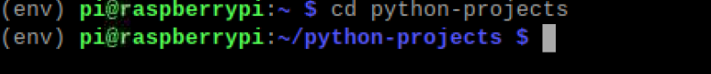

Lastly, we execute our main Python file named ‘airqualitydetector.py’.”

